Peer Evaluation for Inheritance – Lab 1
Your name: (Your lab is the one being evaluated) | John Bell
Name(s) of peer evaluator(s)
Date: | 04/16/17

Instructions
You should have already completed as much of Lab 7 as you can given your time constraints. After you and a peer have evaluated your work, you will submit this evaluation along with screen shots and source code indicated in moodle. You may make corrections to your work as a result of the evaluation.
Wholesale and Retail Customers
Completed Wholesale and Retail Customer classes?  - Created a class diagram in visual studio? Screen shot included?  - Both classes are derived from the Customer class?  - Instance variables are camelCase and private or protected?  - Property/Method names are TitleCase? Properties/Methods are public?  - Overloaded constructor calls the constructor on the base class?  - Added HomePhone to RetailCustomer and Company to WholesaleCustomer?  - Overrides GetDisplayText or ToString or both?  - Completed Retail and Wholesale Customer Tests? Tests all properties and methods in the class? Screen shot is included?  - Source code includes Retail Customer and Wholesale Customer classes and tests? | y

CustomerList2
Completed CustomerList2?  - Created a class diagram in visual studio? Screen shot included?  - Class is derived from List<Customer>?  - Instance variable for the List<Customer> has been removed?  - Methods that are provided by the List class have been removed or marked as new?  - Overloaded constructor calls the constructor on the base class?  - Overrides ToString or both?  - Copied the CustomerList tests? Replaced the list variable data type with CustomerList2. Tests run? Screen shot is included?  - Source code includes CustomerList2 class and tests? | y

BlackjackHand class
Completed BJHand Class?  - Created a class diagram in visual studio? Screen shot included?  - Is derived from Hand class?  - Overloaded constructor calls the appropriate constructor on the base class?  - Instance variable in the Hand class are camelCase and protected? No new instance variables have been added to the BlackjackHand class  - Implements properties/methods specific to a BJHand? What are they?  - Overrides properties/methods appropriately? What are they?  - Tests all properties and methods in the class? Screen shot is included?  - Source code includes class as well as test program? | y

EXTRA CREDIT: Blackjack Console Application
no

Programming style for all programs
Is proper indentation used? Is each event handler indented properly? Is each method indented properly? | y
Are comments used appropriately? | y
Do variable names use camel case? (camelCase for example) | y
Do property/method names use Title Case (or Pascal Case?) | y

General comments and notes:
Screen Shots and Source Code
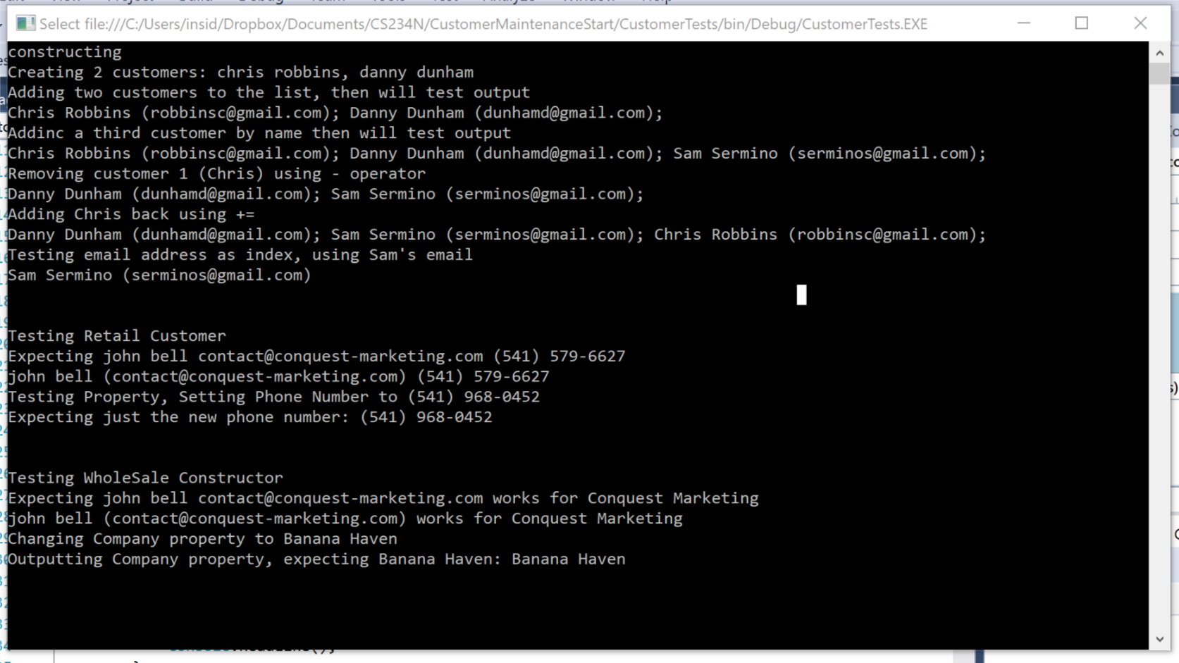

public class WholesaleCustomer : Customer
{

private string company;

public WholesaleCustomer()
{

}

public WholesaleCustomer(string first, string last, string mail, string company) : base(first, last, mail)
{
Company = company;
}

public string Company
{
get { return company; }
set { company = value; }
}

public override string ToString()
{
return base.ToString() + " works for " + Company;
}

}

public class RetailCustomer : Customer
{
private string phone;

public RetailCustomer() { }

public RetailCustomer(string first, string last, string email, string phone) : base(first, last, email)
{
Phone = phone;
}

public string Phone
{
get { return phone; }
set { phone = value; }
}

public override string ToString()
{
return base.ToString() + " " + phone;
}

}

public class CustomerList2 : List<Customer>
{
public CustomerList2() : base()
{

}

public void Fill()
{
List<Customer> customers = CustomerDB.GetCustomers();
foreach (Customer c in customers) {
this.Add(c);
}
}

public Boolean Save()
{
//textbook author website has updated Db class info, look it up foo you need to know this!
try { CustomerDB.SaveCustomers(this); return true; }
catch { return false; }
}

public void Add(string fname, string lname, string email)
{
Customer c = new CustomerMaintenanceClasses.Customer(fname, lname, email);
this.Add(c);
}

public Customer this[string email]
{
get
{
foreach (Customer c in this)
{
if (c.Email == email) return c;
}
return null;
}
}

public static CustomerList2 operator +(CustomerList2 cList, Customer c)
{
cList.Add(c);
return cList;

}

public static CustomerList2 operator -(CustomerList2 cList, Customer c)
{
cList.Remove(c);
return cList;
}
public override string ToString()
{
string s = "";
foreach(Customer c in this)
{
s += c + "; ";
}
return s;
}
}

static void TestCustomerList2()
{
Console.WriteLine("constructing");
CustomerList2 cl = new CustomerList2();
Console.WriteLine("Creating 2 customers: chris robbins, danny dunham");
Customer c1 = new Customer("Chris", "Robbins", "robbinsc@gmail.com");
Customer c2 = new Customer("Danny", "Dunham", "dunhamd@gmail.com");
Console.WriteLine("Adding two customers to the list, then will test output");
cl.Add(c1);
cl.Add(c2);
Console.WriteLine(cl);
Console.WriteLine("Addinc a third customer by name then will test output");
cl.Add("Sam", "Sermino", "serminos@gmail.com");
Console.WriteLine(cl);
Console.WriteLine("Removing customer 1 (Chris) using - operator");
cl -= c1;
Console.WriteLine(cl);
Console.WriteLine("Adding Chris back using +=");
cl += c1;
Console.WriteLine(cl);
Console.WriteLine("Testing email address as index, using Sam's email");
Console.WriteLine(cl["serminos@gmail.com"]);

}

static void TestRetailCustomer()
{
RetailCustomer rc = new RetailCustomer("john", "bell", "contact@conquest-marketing.com", "(541) 579-6627");

Console.WriteLine("Testing Retail Customer");
Console.WriteLine("Expecting john bell contact@conquest-marketing.com (541) 579-6627");
Console.WriteLine(rc);
Console.WriteLine("Testing Property, Setting Phone Number to (541) 968-0452");
rc.Phone = "(541) 968-0452";
Console.WriteLine("Expecting just the new phone number: " + rc.Phone);

}

static void TestWholesaleCustomer()
{
WholesaleCustomer wc = new WholesaleCustomer("john", "bell", "contact@conquest-marketing.com", "Conquest Marketing");
Console.WriteLine("Testing WholeSale Constructor");
Console.WriteLine("Expecting john bell contact@conquest-marketing.com works for Conquest Marketing");
Console.WriteLine(wc);
Console.WriteLine("Changing Company property to Banana Haven");
wc.Company = "Banana Haven";
Console.WriteLine("Outputting Company property, expecting Banana Haven: " + wc.Company);
}

BLACKJACK CLASS

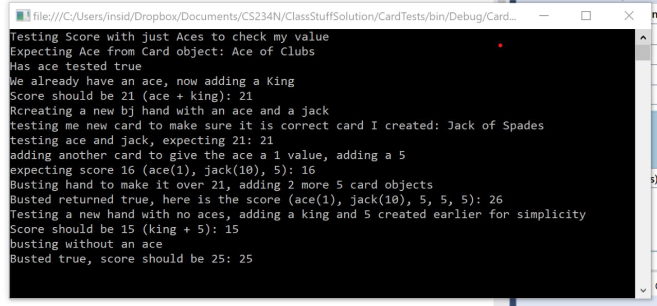

public class BJHand : Hand
{
public BJHand() : base()
{

}

public bool HasAce()
{
return HasCard(14);
}

public int Score
{
get
{
int v =0;
foreach(Card c in hand)
{
if (c.Value <= 9) v += c.Value;
else if (c.Value<=13) v += 10;
else v += 1;

}
if (HasAce() && v <= 11) v += 10;
return v;
}
}

public bool IsBusted()
{
if (Score > 21) return true;
else return false;
}

}

static void TestBJHand()
{
Console.WriteLine("Testing Score with just Aces to check my value");
BJHand bj = new BJHand();
Card c = new Card(14, 1);
bj.Add(c);
Console.WriteLine("Expecting Ace from Card object: " + c);
if (bj.HasAce() == true) {
Console.WriteLine("Has ace tested true");
}
else Console.WriteLine("has ace tested false");

Console.WriteLine("We already have an ace, now adding a King");
Card c2 = new Card(13, 2);
bj.Add(c2);
Console.WriteLine("Score should be 21 (ace + king): " + bj.Score);
Console.WriteLine("Rcreating a new bj hand with an ace and a jack");
BJHand bj2 = new BJHand();
bj2.Add(c);
Card c3 = new Card(11, 3);
Console.WriteLine("testing me new card to make sure it is correct card I created: " + c3);
bj2.Add(c3);
Console.WriteLine("testing ace and jack, expecting 21: " + bj.Score);

Console.WriteLine("adding another card to give the ace a 1 value, adding a 5");
Card c4 = new Card(5, 4);
bj2.Add(c4);
Console.WriteLine("expecting score 16 (ace(1), jack(10), 5): " + bj2.Score);
Console.WriteLine("Busting hand to make it over 21, adding 2 more 5 card objects");
bj2.Add(c4);
bj2.Add(c4);
if (bj2.IsBusted())
Console.WriteLine("Busted returned true, here is the score (ace(1), jack(10), 5, 5, 5): " + bj2.Score);
else Console.WriteLine("Busted returned false");
Console.WriteLine("Testing a new hand with no aces, adding a king and 5 created earlier for simplicity");
BJHand bj3 = new BJHand();
bj3.Add(c2);
bj3.Add(c4);
Console.WriteLine("Score should be 15 (king + 5): " + bj3.Score);
Console.WriteLine("busting without an ace");
bj3.Add(c4);
bj3.Add(c4);
if (bj3.IsBusted() == true)
Console.WriteLine("Busted true, score should be 25: " + bj3.Score);
else Console.WriteLine("Bust failed! Houston you have a problem!");

}

